**Testing for Correlation and Bivariate Regression**

In this analysis, we will use the Afrobarometer dataset that is Merged Round 7 data (34 countries, 2019) which is free to use. The data set is related to the Africans’ views on democracy, governance, and other issues. In this study, we have to perform correlation and bivariate regression which is based on each research question.

**Research Design Questions:**

* The objective of the research question is how much the level of corruption (Q45) impacts the country’s present economic condition (Q4A).
* Does paying bribes for medical care have a correlation (Q49G) between difficulty to obtain medical care (Q49E)?
* Is there a correlation between paying bribes to receive police assistance (Q49R) and difficulty to obtain police assistance (Q49P)?
* Does the country’s present economic condition (Q4A) have a correlation with climate change: affecting the country (Q75) ?

Report descriptive statistics of Q1 variable that is age.

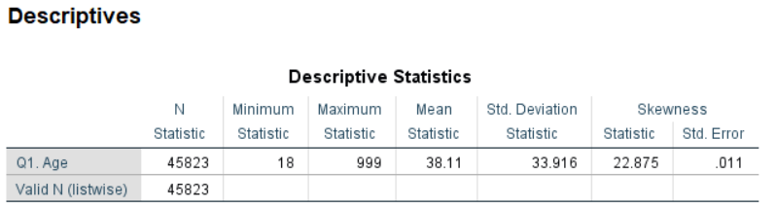

There is no missing data in the Q1 (Age), The mean and standard deviation of Q1 (Age) is 38.11 and 33.916, respectively. On the other hand, the skewness statistic value is 22.875 which indicates that the variable has a highly skewed distribution.

**Analysis Testing**

* How much the level of corruption (Q45) impacts the country’s present economic condition (Q4A).

SPSS Analysis Output:

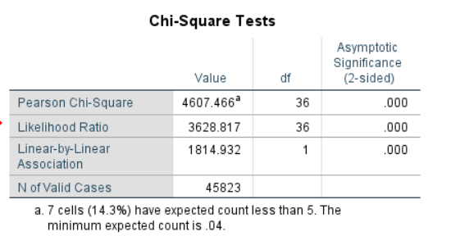

In this test, the assumption is met because it follows that the chi-square approximation to be valid implies that “no more than 20% of the expected counts should be less than 5”.

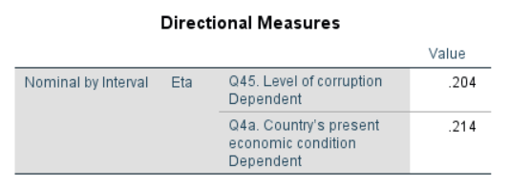

The above result shows the effect size which tells how strong the association is between variables or an effect size gives us a sense of how meaningful the association is. The eta value in this result is close to zero, and the rule of the eta states that if the value is close to zero, then there is no or weak association between the variables, whereas, if the value is close to 1, then there is strong association between the variables. Thus, the eta value is 0.21, we can conclude that the level of corruption is less associated with the country’s present economic condition. However, this is not the real life case because the level of corruption is a factor of GDP and the result is based on the test.

* Does the country’s present economic condition (Q4A) have a correlation with climate change: affecting the country (Q75) ?

SPSS Analysis Output:

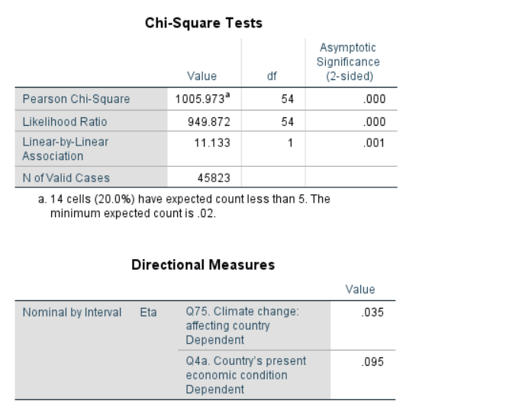

In this case, the chi-square assumption fails because it follows that the chi-square approximation to be valid implies that “no more than 20% of the expected counts should be less than 5”. As the assumption is not violated, the next step is to check the eta value for these variables i.e., close to zero, it indicates that there is no association between the variables.

* Does paying bribes for medical care have a correlation (Q49G) between difficulty to obtain medical care (Q49E)?

SPSS Analysis Result:

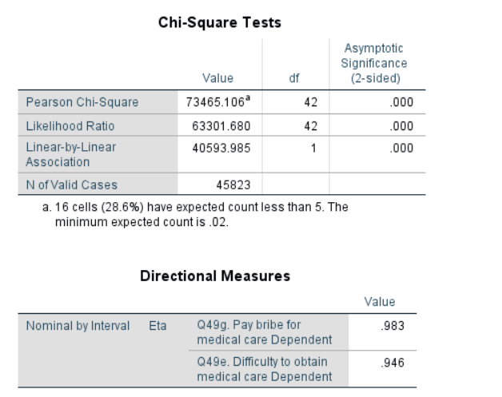

Again in this case, the chi-square assumption fails because it does not follow the chi-square approximation to be invalid implies that “more than 20% of the expected counts should be less than 5”. The assumption is violated, however, if we can check the eta value for these variables, then it indicates that there is a strong association between the paying bribes for medical care (Q49G) and difficulty to obtain medical care (Q49E).

Analysis for above two variables are involved in the bivariate regression.

Result:

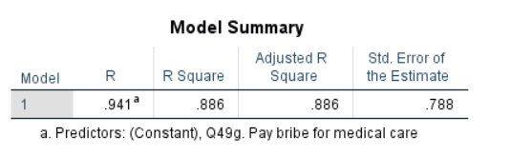

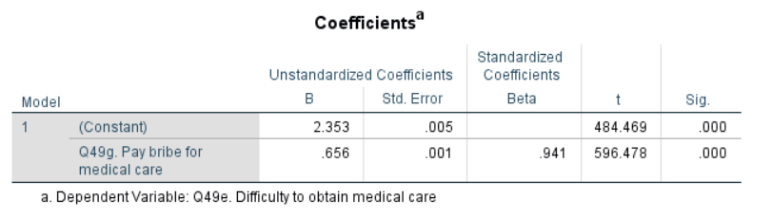

The R-square of the bivariate analysis is 0.941 or 94% which represents the proportion of the variance for a difficulty to obtain a medical care variable that's explained by a pay bribe for the medical care variable in the bivariate regression model.

* Is there a correlation between paying bribes to receive police assistance (Q49R) and difficulty to obtain police assistance (Q49P)?

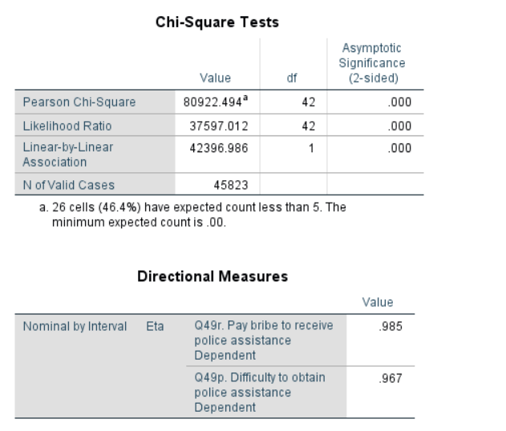\

In this analysis, the chi-square assumption fails because it does not follow the chi-square approximation to be invalid implies that “more than 20% of the expected counts should be less than 5”. The assumption is violated, however, if we can check the eta value for these variables, then it indicates that there is a strong association between paying bribes to receive police assistance and difficulty obtaining police assistance.

**Reference**

Diagnostics, Regression. "Series: Quantitative Applications in the Social Sciences." (1991). Retrieved from DOI: <https://dx.doi.org/10.4135/9781412985604>.

Hurburun, K. S. (2011). An exploratory study aimed at understanding the perceptions of corruption in political leadership with specific reference to Sub-Saharan Africa (Doctoral dissertation, Auckland University of Technology).

Kafle, S. C. (2019). Correlation and regression analysis using SPSS. OCEM J Manag Tech Soc Sci, 1(1), 126-132.

Richardson, J. T. (2011). Eta squared and partial eta squared as measures of effect size in educational research. Educational research review, 6(2), 135-147.

Wagner III, W. E. (2019). Using IBM® SPSS® statistics for research methods and social science statistics. Sage Publications.